Dr.I.CARMEL MERCY PRIYA,M.B.A.,M.Phil.,Ph.D.,

PRINCIPAL Date: 17.02.2022

**CIRCULAR**

This is to inform you that the Department of Computer Applications, AVS College of Arts & Science conducts a One day Seminar on **“MACHINE LEARNING &ARTIFICIAL INTELLIGENCE”** to develop knowledge on manages and operates data storage as a service. This programme mainly focuses on, The goal of artificial intelligence (AL) and machine learning is to program me computers to use example data(or)experience to solve a given problem,and it is scheduled on 8.03.222. The students, those who are interested, can enroll their name on or before 24.02.2022 and for more details contact Mrs.R.Parimala, Head, Department of Computer Applications.

CONVENOR PRINCIPAL

**Copy to all Department Heads**

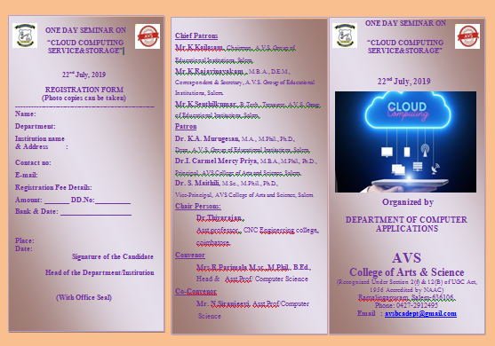

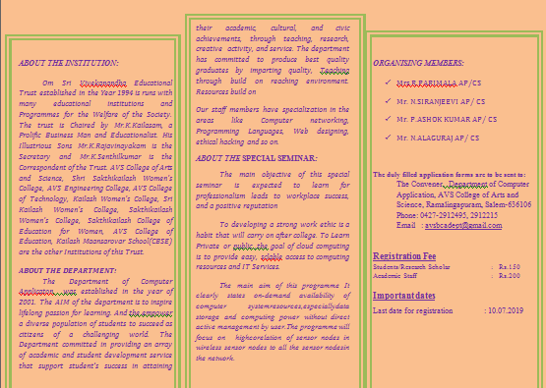

**DEPARTMENT OF COMPUTER APPLICATIONS**

**REPORT OF SEMINAR ON**

**“MACHINE LEARNING &ARTIFICIAL INTELLIGENCE”**

Department of Computer Applications, AVS College of Arts & Science organized a Seminar on “MACHINE LEARNING & ARTIFICIAL INTELLIGENCE” on 08.03.2022 a Nethaji Seminar Hall. The details of the program are:

| 1. | Name of the Event  (Seminar/Workshop/Conference/FDP  Webinar/Any others) | Seminar |
| --- | --- | --- |
| 2. | Name of the Department | Computer applications |
| 3. | Date of the Event | 08.03.2022 |
| 4. | Venue of the Event  Conducted | Nethaji Seminar Hall |
| 5. | Title of the Event | Machine learning & Artificial intelligence |
| 6. | Name of the Convener | Mrs. R. Parimala, Msc., M. Phil., B.Ed.,  Assistant Professor  Department of Computer Applications  AVS College of Arts & Science |
| 7. | Name & Address of the  Resource Person | Dr. R. Thiyagarajan, MCA.,M.Phil.,Ph.D.,  Assistant Professor,  CNC Engineering College, Covai.  Email:Thiyagu07@gmail.com  Contact:91 7356578676 |
| 8. | Total Participants | 88 |
| 9. | Objective of the Event | * 1. To learn The overall research goal of artificial intelligence is to create technology that allows computers and machines to work intelligently. * To understand Artificial intelligence (AI) makes it possible for machines to learn from experience, adjust to new inputs and perform human-like tasks |
| 10. | Outcome of the Event | After the successful completion of the seminar, student will able to :  1. Apply. he primary purpose of machine learning is to discover patterns in the user data and then make predictions based on these and intricate patterns for answering business questions and solving business problems. Machine learning helps in analysing the data as well as identifying trends  2. Understand how to evaluate models generated from data. Apply the algorithms to a real problem, optimize the models learned and report on the expected accuracy that can be achieved by applying the models |

**SUMMARY OF EVENT**

One-day Seminar on “Machine learning & artificial intelligence” was organized by the Department of Computer Applications on 8th March 2022 in Nethaji Seminar Hall, AVS College of Arts & Science. The main objective of this event is to provide easy, scalable access to computing resources and IT services and including servers, storage, databases, networking, software, analytics, and intelligence over the Internet. A total of 88students have participated in this Seminar from various departments.

The event was started with an inaugural address delivered by Mrs. R. Parimala, Assistant Professor, Department of Computer Application, AVS College of Arts & Science, and she extended his warm welcome to the participants and resource person of the programmer. She also thanked Dr. R. Thiyagarajan Assistant Professor CNC Engineering College Kovai.

Finally, he concluded his speech with a artificial intelligence and machine learningis to programme computers to use example data. Dr. R. Thiyagarajan, Resource Person responded to the questions and clarified the doubts of the participants. The session was concluded by a vote of thanks from Mrs. R. Parimala, Assistant Professor and Department of Computer Applications. She expressed special gratitude for informative and useful presentations. She gave his sincere thanks to all the participants and staff members for participating and making the programme grand success.

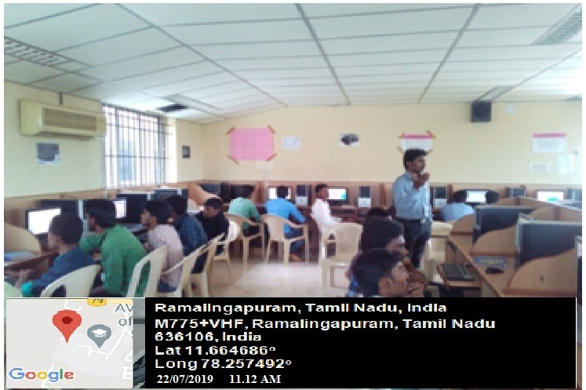

Resource Person Dr. R. Thiyagarajan, MCA.,M.Phil.,Ph.D., is explaining to the students about the concept and importance of Cloud Computing Service & Storage.

**RESOURCE PERSON PROFILE**

Dr. R. Thiyagarajan is working as a Assistant Professor, CNC Engineering College, Covai. He had Teaching Experience 14 years, Research experience 10 years. He is Assistant Director, Directorate of Online Programmers Kovai. Research supervision PhD 4 Completed, 6 ongoing, Project PG 82 Completed, 10 ongoing. International Journals 27, Conferences 09, National conferences 14 and books published 04. Resource Person has more than 15 years of experience in Teaching with knowledge in consulting, Designing and customizing and delivering technical training on enterprise students Software Platforms and experienced.

**SIGNATURE OF CONVENER** **PRINCIPAL**

**DEPARTMENT OF COMPUTER APPLICATIONS**

**One day Seminar on**

**“Machine Learning &Artificial Intelligence”**

**STUDENT ATTENDANCE REGISTER (DATE: 08.03.2022)**

|  |  |  |  |  |
| --- | --- | --- | --- | --- |
| **S.NO** | **REGISTER NUMBER** | **NAME OF THE STUDENT** | **DEPARTMENT** | **SIGNATURE** |
| 1 | 20UCA1336 | ANUSUYA A | BCA |  |
| 2 | 20UCA1400 | ASHOKKUMAR R | BCA |  |
| 3 | 20UCA1401 | BALAJI R | BCA |  |
| 4 | 20UCA1337 | BOOPATHI RAJA R | BCA |  |
| 5 | 20UCA1338 | DEEPIKA R | BCA |  |
| 6 | 20UCA1402 | DHANUSH M | BCA |  |
| 7 | 20UCA1339 | DHATCHANAMOORTHI R | BCA |  |
| 8 | 20UCA1340 | DHILIP KUMAR M | BCA |  |
| 9 | 20UCA1341 | DHINA P | BCA |  |
| 10 | 20UCA1342 | DHINESH R | BCA |  |
| 11 | 20UCA1343 | DINESH B S | BCA |  |
| 12 | 20UCA1344 | DINESHKUMAR R | BCA |  |
| 13 | 20UCA1345 | ELAVARASAN M | BCA |  |
| 14 | 20UCA1346 | GANESHSANKAR V | BCA |  |
| 15 | 20UCA1347 | GOKUL KANNAN M | BCA |  |
| 16 | 20UCA1348 | GOKULAKANNAN K | BCA |  |
| 17 | 20UCA1349 | GRITH S | BCA |  |
| 18 | 20UCA1350 | HARISH M | BCA |  |
| 19 | 20UCA1351 | JEEVANANTH C | BCA |  |
| 20 | 20UCA1352 | JEEVANANTHAM N | BCA |  |
| 21 | 20UCA1353 | KALAISELVAN P | BCA |  |
| 22 | 20UCA1354 | LOGESH M | BCA |  |
| 23 | 20UCA1355 | DHARANIDHARAN L |  |  |
| 24 | 20UCA1356 | DHILIP S | BCA |  |
| 25 | 20UCA1357 | DHINA T | BCA |  |
| 26 | 20UCA1358 | DINAKARAN A | BCA |  |
| 27 | 20UCA1359 | DINESH V | BCA |  |
| 28 | 20UCA1360 | DIVAN J | BCA |  |
| 29 | 19UCS6009 | ELANGOVAN N | CS |  |
| 30 | 19UCS6010 | ELAVARASAN A | CS |  |
| 31 | 19UCS6011 | GAYATHRI B | CS |  |
| 32 | 19UCS6012 | GITHENDRAN M | CS |  |
| 33 | 19UCS6013 | GOKUL M | CS |  |
| 34 | 19UCS6014 | GOKULAKANNAN K | CS |  |
| 35 | 19UCS6015 | GOKULNATHAN B | CS |  |
| 36 | 19UCS6087 | GOKUL NATHAN S | CS |  |
| 37 | 19UCS6088 | GOKULRAJ B | CS |  |
| 38 | 19UCS1812 | GOKULRAJ S | CS |  |
| 39 | 19UCS1813 | GOKULRAJ S | CS |  |
| 40 | 19UCS1815 | GOPI S | CS |  |
| 41 | 19UCS1816 | HARIHARAN P | CS |  |
| 42 | 19UCS1817 | HARISHKUMAR V | CS |  |
| 43 | 19UCS1819 | JEEVANANTHAM B | CS |  |
| 44 | 19UCS1924 | KABILDASS G | CS |  |
| 45 | 19UCS1925 | KARTHICK P | CS |  |
| 46 | 19UCS1926 | KARTHICK R | CS |  |
| 47 | 19UCS1927 | KARTHIKEYAN V | CS |  |
| 48 | 19UCS1928 | KASI PRASANTH S | CS |  |
| 49 | 19UCS1929 | RAMESH P | CS |  |
| 50 | 19UCS1931 | SAKTHI S | CS |  |
| 51 | 19UCS1932 | SAKTHIBALAN P | CS |  |
| 52 | 19UCS1933 | SARATHKUMAR S | CS |  |
| 53 | 19UCS1934 | SATHYAKUMAR A | CS |  |
| 54 | 19UCS1935 | SENTHILKUMAR M | CS |  |
| 55 | 19UCS1936 | SENTHIL KUMAR P | CS |  |
| 56 | 19UCS1937 | SIVA KUMAR S | CS |  |
| 57 | 19UCS1938 | SIVASANKAR S | CS |  |
| 58 | 19UCS1939 | SUGUMAR V | CS |  |
| 59 | 19UCS1940 | SURIYA S | CS |  |
| 60 | 19UCS1941 | SURYA A | CS |  |
| 61 | 19UCS1942 | TAMILSELVAN R | CS |  |
| 62 | 19UCS1944 | THILAGAVATHI K | CS |  |
| 63 | 19UCS1945 | THILLAIARASAN K | CS |  |
| 64 | 19UCS1946 | UDAYANITHI C | CS |  |
| 65 | 19UCS1947 | AAKASH M | CS |  |
| 66 | 19UCS1948 | AJAY N | CS |  |
| 67 | 19UCS1949 | AJITH R | CS |  |
| 68 | 19UCS1950 | AJITH V | CS |  |
| 69 | 19UCS1951 | AJITHKUMAR P | CS |  |
| 70 | 19UCS1952 | AKASHRAJ R | CS |  |
| 71 | 19UCS1953 | AMANI BYEMBA QUEEN | CS |  |
| 72 | 19UCS1954 | ANAS T | CS |  |
| 73 | 19UCS1955 | ANBARASU S | CS |  |
| 74 | 19UCS1956 | ARAVINDHKUMAR A | CS |  |
| 75 | 19UCS1957 | ARISHWAR B | CS |  |
| 76 | 19UCS1958 | ARULKUMAR B | CS |  |
| 77 | 19UCS1959 | ARULMANI A | CS |  |
| 78 | 19UCS1960 | ARULSRI A | CS |  |
| 79 | 19UCS1961 | DHINESH S | CS |  |
| 80 | 19UCS1962 | DHINESH S | CS |  |
| 81 | 19UCS1963 | DINAKARAN J | CS |  |
| 82 | 19UCS1964 | DINESH M | CS |  |
| 83 | 19UCS1965 | DINESH R | CS |  |
| 84 | 19UCS1863 | ELANGOVAN B | CS |  |
| 85 | 19UCS1864 | ELAVARASAN T | CS |  |
| 86 | 19UCS1865 | ELAVARASU M | CS |  |
| 87 | 19UCS1866 | GNANAJOTHIMURUGAN V | CS |  |
| 88 | 19UCS1867 | GOKULAKRISHNAA P | CS |  |